

**CSE360: Computer Interfacing**

**Project Based Assignment**

**Heart Rate and Body Temperature Monitoring System along with Room Condition**

**Submitted by:**

| **Student ID** | **Name** |
| --- | --- |
| 17301149 | Tanjid Alam Kabbo |
| 17301078 | Motakabbir Hossain |
| 18301276 | Imam Hossain |
| 18101671 | Rownak Tahmid |

**Section: 02**

**Submitted to:**

**Shakir Rouf**

**Lecturer**

**Date:** 26.12.21

**Introduction:**

In our endeavour to reach our goals we often forget about our health. However, this should not have been the case as health is the center of happiness. Keeping that health in mind we came up with our temperature and heart rate monitoring system. This system can monitor the heart rate and temperature of people at any age. As health is our main concern we made our system cheap so that it is easily accessible to anyone rich or poor. In addition to this keeping eldarly people in mind we have added extra features that can monitor the temperature and humidity of a room. One thing we all have to keep in mind is that ‘Prevention is better than cure’ that is why to prevent any dire health complications in the future our system will warn everyone that is our aim and our goal.

**Application area:**

Our system uses LM35 temperature sensor so that it can monitor any changes of body temperature. In addition to this heart rate pulse sensor will be giving updates about our heart beat rate. This system is made keeping labours and elderly in mind, however it can be used by anyone as our system has no age limit and it is genderless. The initial reason for keeping labour and elderly in mind is because they are much more prone to neglect their health than others. In addition to this we went an extra mile and added temperature and relative humidity sensors so that it can warn elderly people about which room or places to avoid that can cause health complications.

**Technology and Tools:**

* Breadboard
* Arduino uno R3
* DHT11 Temperature and relative humidity sensor
* Heart rate pulse sensor
* Standard LCD 16x2
* LM35 temperature sensor
* 5mm red LED
* 1/4w resistor
* Jumper wire

**Language**

Programming for the Arduino is done in C/C++ and adheres to a strict set of rules. Programming languages such as C/C++ are accessible to the general public. A "sketch," the name given to Arduino code files, is created and processed using the Arduino IDE, which compiles the code into machine language. The Arduino IC acts as the code's instruction.

**Working mechanism of Sensors**

**Mechanism of DHT11 Sensor**

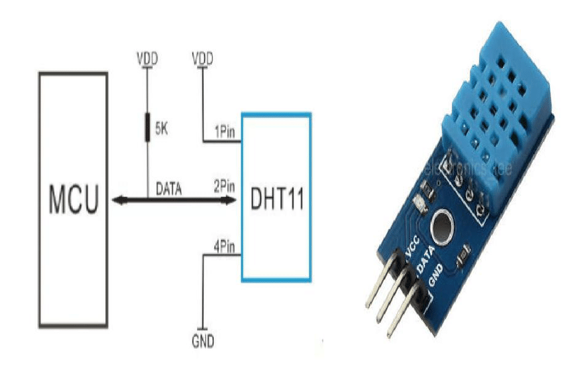

Keeping a track of humidity and temperature values of a room where people can be affected by these, is essential. The DHT11 sensor is a low-cost digital sensor which does this job properly . It has a capacitive humidity sensing element and a thermistor to measure the humidity and temperature of its surroundings. It also has an 8-bit microcontroller connected to it to output the values of temperature and humidity as serial data. After measuring the surrounding air it sends a digital signal to the data pin. For sensing humidity, its capacitor has two electrodes which use a moisture holding substrate as dielectric. The change of capacitance value determines the change of humidity. As for measuring temperature it uses NTC thermistor which creates a decrease in the resistance value with increase in the temperature value.

**Mechanism of Heart Rate Pulse Sensor**

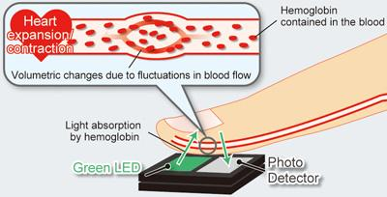

For a patient or a person who does heart-related interactive work, sometimes it is very crucial to monitor the heart rate regularly since it gives us an overall idea about the health condition of that person. Heart rate sensor is a very effective digital sensor to serve this purpose. It has a simple optical heart rate sensor and amplification with noise cancellation circuitry. When the heart pumps blood, a change in the volume of blood vessels occurs, this change of volume is called pulse wave and a detector detects this volume change which is known as Heart rate pulse sensor. The volume changes in the blood vessels of an organ is measured by the changes in the intensity of the light passing through that organ. The sensor emits red, infrared or green light through the body and then using a phototransistor or photodiode it measures the total light reflection. The blood of our arteries contains oxygenated hemoglobin which has the characteristic of absorbing incident light, therefore by sensing the rate of blood flow that changes after heart contractions over a certain period of time we can measure the pulse wave signal.

**Mechanism of LM35 Temperature Sensor**

The LM35 Temperature sensor is a low voltage and linear temperature sensor which gives an analog signal according to the output voltage which varies proportionally with the change in the temperature. The LM35 sensor works on the basic principle of diode and to measure the temperature it uses solid-state technique.In the centre of the circuit there are two transistors. Since the amount of the current flowing through them is the same, therefore one of them has 10 times greater current density than the other because of its 10 times smaller emitter area. This causes a voltage. When the temperature increases, the voltage drop between the base and emitter of the diode connected transistor decreases at a certain rate. Then an analog signal output is generated with which the change in temperature is proportional. In LM35 sensors an increased output of 10 millivolts means the rising of the temperature by 1 degree celsius.

**Connection With ICs**

**LCD with Arduino:**

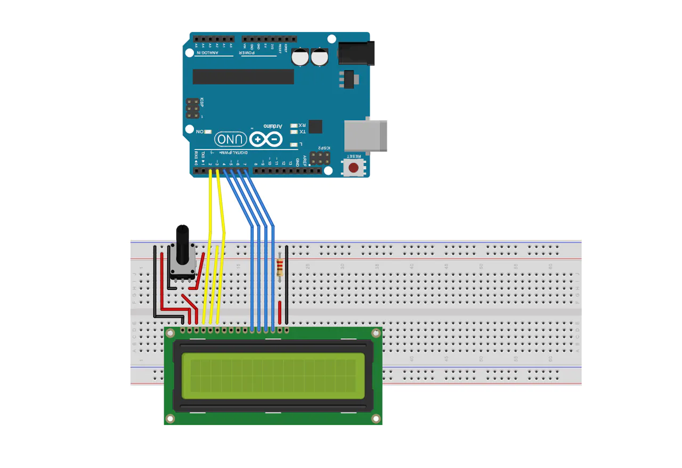

In our project, we will be using 16*2 LCD which can display 32 ASCII characters in 2 rows and 16 characters in each row. LCDs are really useful and easy to implement when we need to display any characters or texts. The GND pin should be connected to the ground of the Arduino. The VCC pin works as the power supply pin for the LCD and it is connected to the 5 volts pin on the Arduino. Using the Vo pin contrast and brightness of the LCD can be controlled using a voltage divider with a potentiometer. We need to connect pin 15 to the VCC and pin 16 to the ground for powering the backlight. The contrast and brightness controller Pin number 3 will be connected to the center pin of a potentiometer and the potentiometer will be connected between a voltage source and ground. Pin 7-pin14 are used for transferring data. But the HD44780 LCD doesn’t always need all these data pins for transferring data. We have the option to use only four pins for transferring data. We are going to use 4 bit transfer mode for transferring data as we don’t have a lot of vacant pins on the Arduino in this project. Now we only need to configure EN, RS, D7, D6, D5, D4 for viewing data. D4-D7 pins need to be connected to the Arduinos pin 4- pin 7. The Enable pin (pin 6) needs to be connected to the Arduinos pin 2 and the RS pin (pin 4) needs to be connected to the Arduinos pin 1.

**Heart rate sensor with Arduino:**

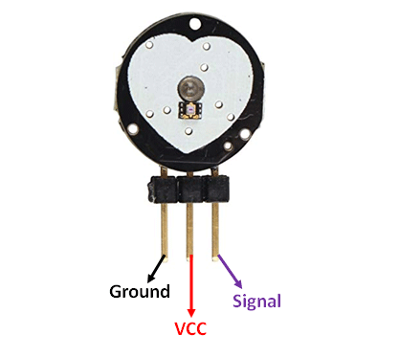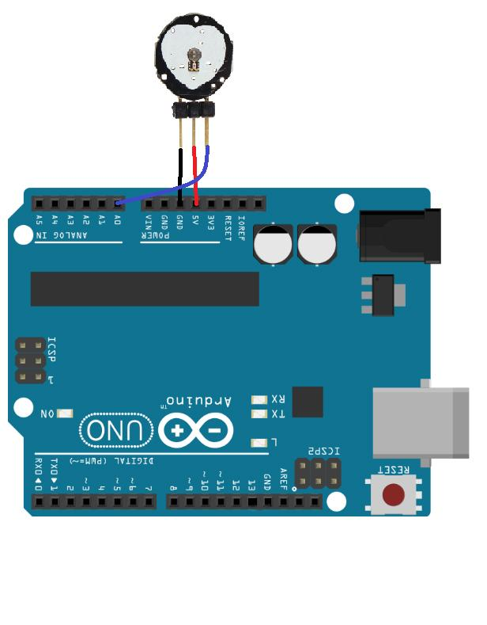

To measure heart rate we are using the SEN-11574 sensor. It has 3 pins, one analog signal pin (s), one VCC(+) pin and one GND(-) pin. The analog signal pin is connected to the A0 pin of the Arduino, (+) is connected to the VCC and (-) pin is connected to the ground pin of the Arduino.

**DHT11 Sensor with Arduino:**

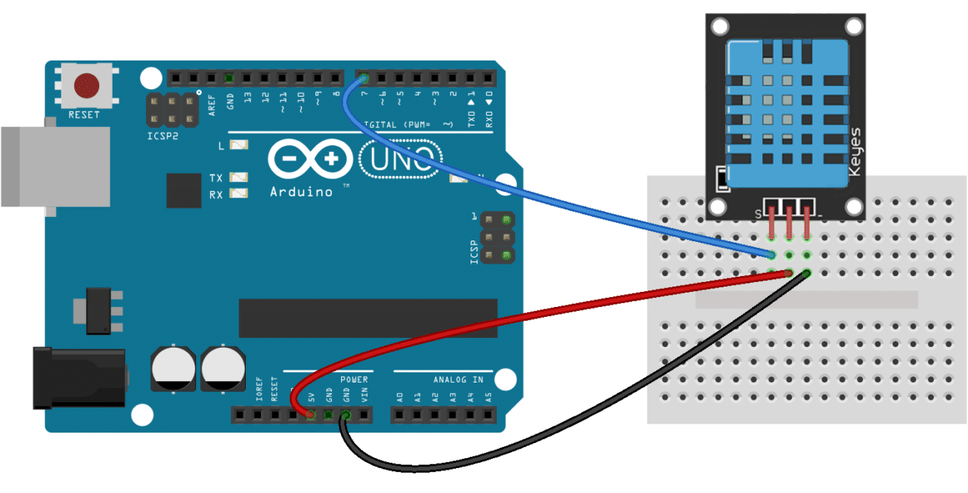

We will be using a DHT11 sensor of 3 pins which is for measuring the temperature and humidity of the room. To supply the power to the sensor, we will connect the 1st pin of DHT11 sensor with the VCC of Arduino UNO. For transferring data to the IC, the 2nd pin will be connected with the digital pin 7 of Arduino UNO. Lastly, the 3rd pin should be connected with the GND of Arduino UNO.

**Temperature sensor with Arduino:**

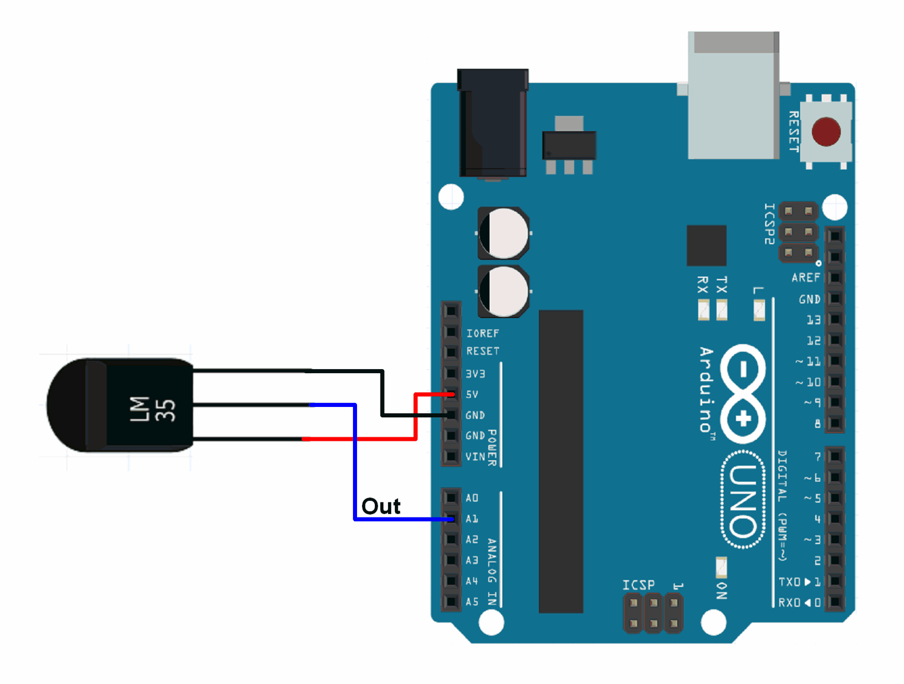

We have taken a LM35 temperature sensor for measuring the body temperature. We will connect the VCC and the ground pin of LM35 with VCC and GND of Arduino UNO respectively and to send data, we will connect the output pin with the A1 pin of Arduino UNO.

**LED with Arduino:**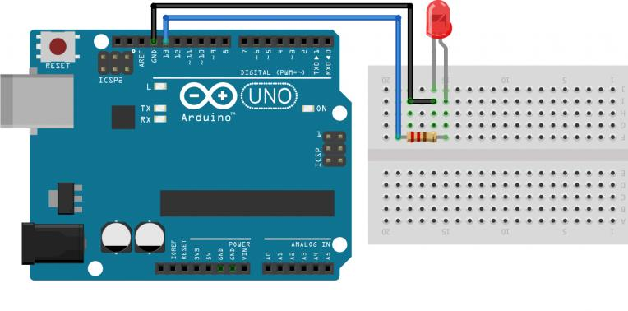

In our project, we will use a RED LED to warn the person when body temperature gets higher than 100 degree fahrenheit. We will connect one pin to GND of Arduino UNO through a resistor and another pin to digital pin 13 of Arduino UNO.

**Data flow from sensors through ICs to I/O devices**

**DHT11 sensor to IC:**

To measure humidity, DHT11 detects water vapor by measuring the electrical resistance between two electrodes and it measures temperature with a surface mounted NTC temperature sensor(thermistor) built into the unit. The DHT11 uses just one signal wire to transmit data to the Arduino. Here in the project, it will send the data to IC through digital pin 7 of Arduino UNO. Power comes from separate 5V and ground wires. A 10K Ohm pull-up resistor is needed between the signal line and 5V line to make sure the signal level stays high by default.

**Temperature sensor to IC:**

The LM35 is an inexpensive, precision Centigrade temperature sensor made by [Texas Instruments](https://www.ti.com/product/LM35#product-details##params). It provides an output voltage that is linearly proportional to the Centigrade temperature and is, therefore, very easy to use with the Arduino. It sends analog signals to IC through one signal wire. In our project, we will use a 3-pin LM35 which will send the analog data to the analog pin A1 of Arduino UNO.

**Heart rate sensor through IC to I/O devices:**

To read and write data from a heart rate sensor, an Arduino IDE library called 'PulseSensor' must be installed. A heart rate sensor is a device that converts a physical quantity, such as light intensity, into an electrical quantity. The voltage difference is used by Arduino to detect the change. The output of the sensor is connected to an analog input on the Arduino. The analog-to-digital converter (ADC) on the Arduino then translates that value to a number between 0 and 1023. After that, this value is mapped to a number between 0 and 255**.**

**IC to LCD:**

As there are not enough pins on the Arduino board, we'll use 4bit mode data transfer for the LCD. Data is transferred using only four data bus pins in this data transfer mode. When it receives data, RS (register select) will be high, and when it receives commands, it will be low. Data is read or written via the R/W pin. We'll only use it for the write command here. The R/W (pin 5) will be grounded as a result. Only the data bus pins (11-14) will be used for data transport. There are other times for set-up and hold that must be factored in. This permits signal levels to stabilize and ensures that pins are sampled at the appropriate times. Because we're in 4bit mode, 8 bit data or instructions will be delivered to the LCD in two halves. Character 1 will be split into two halves if we wish to send it to the LCD. The 8-bit ASCII equivalent of character 1 is 0x30 or 0011 0000, thus we'd send 0011 (upper nibble) on the data bus before sending 0000. (lower nibble). We can see pulse values from the pulse sensor as well as temperature and humidity from the DPS310 sensor on this LCD. These sensors send data to the IC, which then sends it to the LCD. These combinations are simple to implement using the Arduino IDE.

**IC to LED:**

A RED LED will be used in our project to warn the person when temperature crosses the threshold value. When the Arduino reads a value more than the threshold value from the temperature sensor, immediately it will send the output signal through its digital pin 13 to turn the LED on.

**Estimated cost analysis**

Breadboard (medium size) – 65 BDT

Arduino uno R3 – 640 BDT

DHT11 Temperature and relative humidity sensor – 180 BDT

Heart rate pulse sensor – 299 BDT

Standard LCD 16x2 – 159 BDT

LM35 temperature sensor – 71 BDT

5mm red LED(pack of 5) – 5 BDT

Kiloohm (KΩ) 1/4w Resistors (Pack of 5) – 5 BDT

Jumper wire (40 pcs set) – 90 BDT

The total estimated price for the demo device would be 1514 BDT.

**Responsibilities of each member**

We conducted all of our discussions and communication through google meet and Discord server. Everyone did their part responsibly, otherwise we could not have done this project in time. We all discussed and agreed before implementing every part of the project.

**Tanjid Alam Kabbo:** Wiring LCD with Arduino, Wiring Heart rate sensor with the Arduino, Diagrams, Workplan, Data flow from Heart rate sensor through IC to I/O devices, Data flow from IC to LCD.

**Motakabbir Hossain:** Introduction, Application Area, Technology and tools, Conclusion.

**Imam Hossain:** Wiring DHT11 Sensor with Arduino, Wiring Temperature sensor with Arduino, Wiring LED with Arduino, Data flow from sensors through ICs to I/O devices.

**Rownak Tahmid:** Language, Mechanism of DHT11 sensor, Mechanism of Heart rate sensor, Mechanism of LM35 Temperature sensor, Estimated cost analysis.

**Workplan (Gantt Chart)**

**Assignment Work Plan**

|  | **Week 1** | | | | | | | **Week 2** | | | | | | |
| --- | --- | --- | --- | --- | --- | --- | --- | --- | --- | --- | --- | --- | --- | --- |
| **Activity** | **13** | **14** | **15** | **16** | **17** | **18** | **19** | **20** | **21** | **22** | **23** | **24** | **25** | **26** |
| **Group meeting 1: Project Selection** |  |  |  |  |  |  |  |  |  |  |  |  |  |  |
| **Research about project** |  |  |  |  |  |  |  |  |  |  |  |  |  |  |
| **Group meeting 2: Finalizing Project** |  |  |  |  |  |  |  |  |  |  |  |  |  |  |
| **Making Final Project** |  |  |  |  |  |  |  |  |  |  |  |  |  |  |
| **Group meeting 3** |  |  |  |  |  |  |  |  |  |  |  |  |  |  |

**Project work plan estimation**

| **Task** | **Jan** | **Feb** | **Mar** | **Apr** | **May** | **Jun** | **Jul** | **Aug** | **Sep** |
| --- | --- | --- | --- | --- | --- | --- | --- | --- | --- |
| **Planning** |  |  |  |  |  |  |  |  |  |
| **Research** |  |  |  |  |  |  |  |  |  |
| **Design** |  |  |  |  |  |  |  |  |  |
| **Implementation** |  |  |  |  |  |  |  |  |  |

**Conclusion:**

This project that we have done will save millions of time and money as our project ensures that we don’t need to visit doctors regularly but visit them when it is necessary. However, this project also has a little bit of a problem and that our project is not easily portable like a band or a watch etc. It can be taken from one place to another like a mobile or tv remote etc. To handle this problem the end product of our project is easily purchasable, as our project is very user friendly and cost efficient. In the end we are hoping that our system can save millions of precious time and precious lives.

**References:**

*, N. (2019, August 06). DHT11 sensor definition, working and applications. Retrieved December 26, 2021, from https://www.elprocus.com/a-brief-on-dht11-sensor/

*, N. (2019, September 11). Pulse sensor : Pin Diagra,. Working, Circuit Diagram & Its Applications. Retrieved December 26, 2021, from https://www.elprocus.com/pulse-sensor-working-principle-and-its-applications/

Administrator. (2021, September 08). Heartbeat Sensor using Arduino (heart rate monitor). Retrieved December 26, 2021, from https://www.electronicshub.org/heartbeat-sensor-using-arduino-heart-rate-monitor/

Interface a 16x2 character LCD. (n.d.). Retrieved December 26, 2021, from https://create.arduino.cc/projecthub/ejshea/interface-a-16x2-character-lcd-1c7c7e

Last Minute Engineers. (2021, December 07). In-depth: Interfacing LM35 temperature sensor with Arduino. Retrieved December 26, 2021, from https://lastminuteengineers.com/lm35-temperature-sensor-arduino-tutorial/

Teja, R. (2021, February 27). How to interface LM35 temperature sensor with Arduino? Retrieved December 26, 2021, from https://www.electronicshub.org/arduino-lm35-temperature-sensor/